**ContractNest Second Round Of Testing-**

**QA- Nilesh Deulkar**

**Release Date-15-Jan-2026**

Modules- Contacts and Settings.

Test user- [nileshdeulkar212@gmail.com](mailto:nileshdeulkar212@gmail.com)

Password- Test@2025

**New registration: error occurs while trying to register RESOLVED**

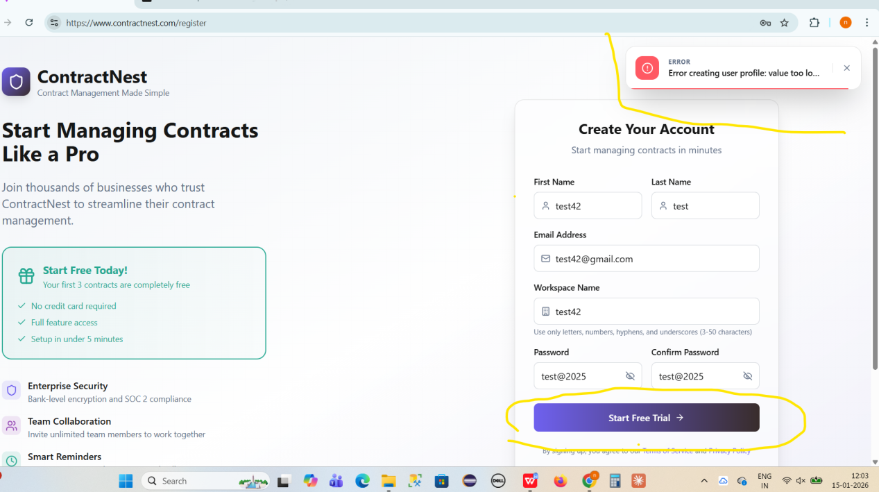

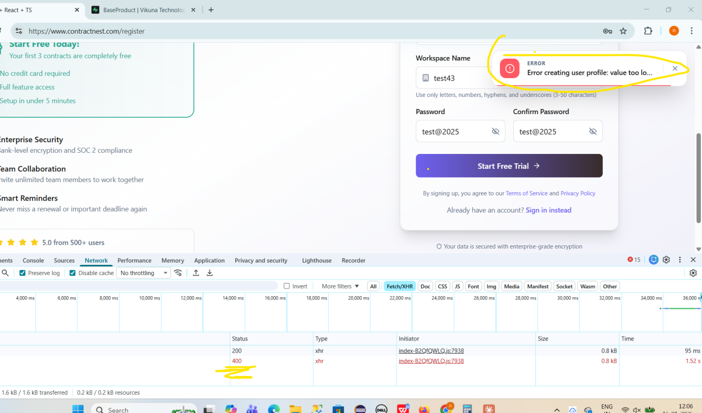

Logs----

POST https://contractnest-api-production.up.railway.app/api/auth/register 400 (Bad Request)

(anonymous) @ index-B2QfQWLQ.js:7938

apply @ index-B2QfQWLQ.js:7938

(anonymous) @ index-B2QfQWLQ.js:62

xhr @ index-B2QfQWLQ.js:62

iee @ index-B2QfQWLQ.js:64

Promise.then

_request @ index-B2QfQWLQ.js:65

request @ index-B2QfQWLQ.js:64

(anonymous) @ index-B2QfQWLQ.js:65

(anonymous) @ index-B2QfQWLQ.js:60

ae @ index-B2QfQWLQ.js:7938

$ @ index-B2QfQWLQ.js:8830

WX @ index-B2QfQWLQ.js:48

(anonymous) @ index-B2QfQWLQ.js:48

tY @ index-B2QfQWLQ.js:48

cz @ index-B2QfQWLQ.js:48

kz @ index-B2QfQWLQ.js:49

y0e @ index-B2QfQWLQ.js:49

n @ index-B2QfQWLQ.js:7938

**Onboarding Issues---**

**While updating the First Name and Last Name for a newly registered user in profile section, the system throws a “Validation Failed” error and the details are not updated. RESOLVED**

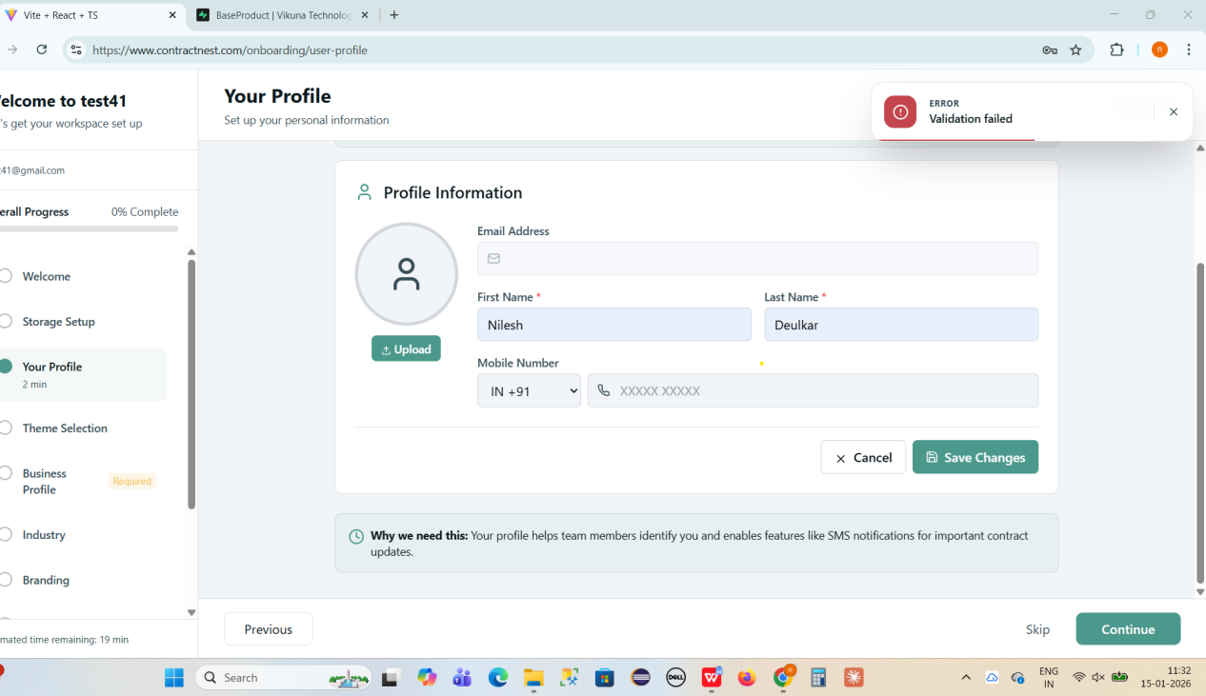

**Avatar upload is failing, but no error message is displayed and no error logs are generated in the browser and jpg file is not uploaded for old tenants RESOLVED** 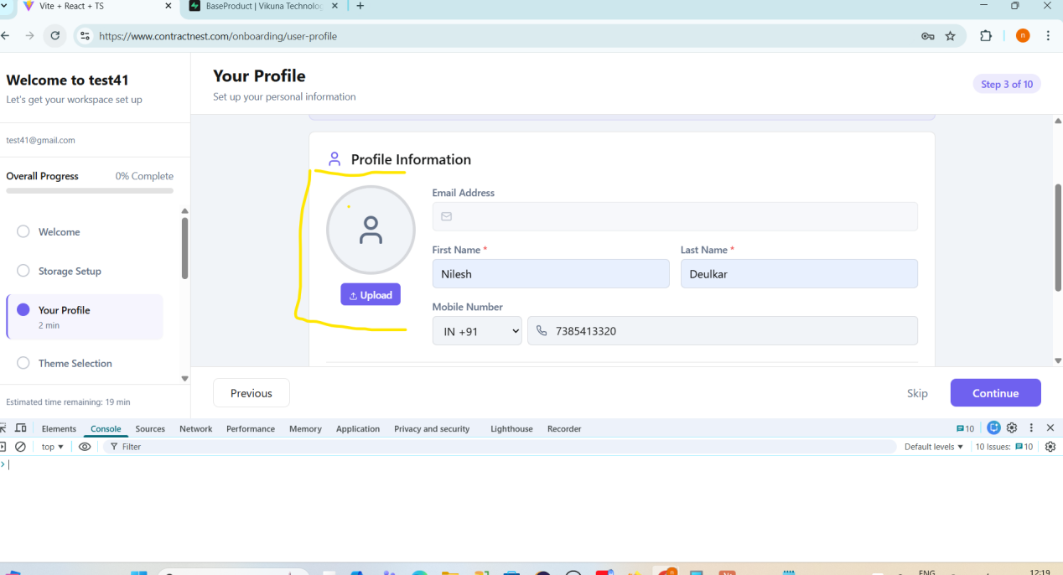

**While updating the application theme or changing the theme mode (e.g., light to dark), the application throws an error and the update does not complete successfully. RESOLVED**

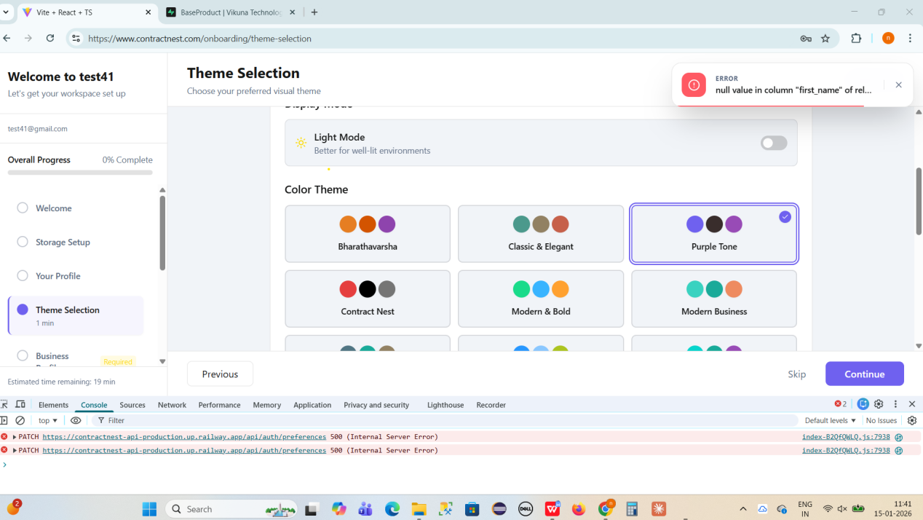

Logs-

index-B2QfQWLQ.js:7938 PATCH https://contractnest-api-production.up.railway.app/api/auth/preferences 500 (Internal Server Error)

(anonymous) @ index-B2QfQWLQ.js:7938

apply @ index-B2QfQWLQ.js:7938

(anonymous) @ index-B2QfQWLQ.js:62

xhr @ index-B2QfQWLQ.js:62

iee @ index-B2QfQWLQ.js:64

Promise.then

_request @ index-B2QfQWLQ.js:65

request @ index-B2QfQWLQ.js:64

(anonymous) @ index-B2QfQWLQ.js:65

(anonymous) @ index-B2QfQWLQ.js:60

tt @ index-B2QfQWLQ.js:7938

d @ index-B2QfQWLQ.js:8868

onClick @ index-B2QfQWLQ.js:8868

WX @ index-B2QfQWLQ.js:48

(anonymous) @ index-B2QfQWLQ.js:48

tY @ index-B2QfQWLQ.js:48

cz @ index-B2QfQWLQ.js:48

kz @ index-B2QfQWLQ.js:49

y0e @ index-B2QfQWLQ.js:49

n @ index-B2QfQWLQ.js:7938

**Skip button is inactive during new tenant onboarding NOT A BUG**

**Issue Description- Application throwing an error while business profile creation**

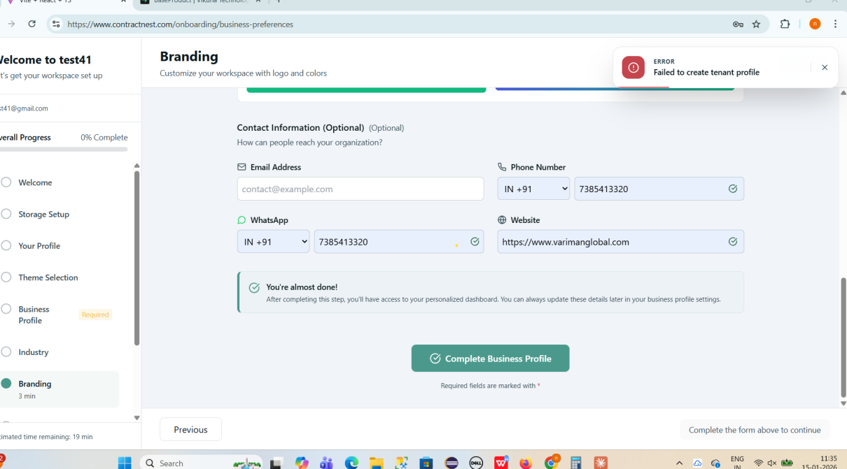

**Settings-Configure-Team Management-Invite User**

**Issue Description--While sending an invite to a user, the Phone Number field accepts more than 10 digits and also does not show any error when fewer than 10 digits are entered. Additionally, the application navigates out of the Invite User page unexpectedly.**

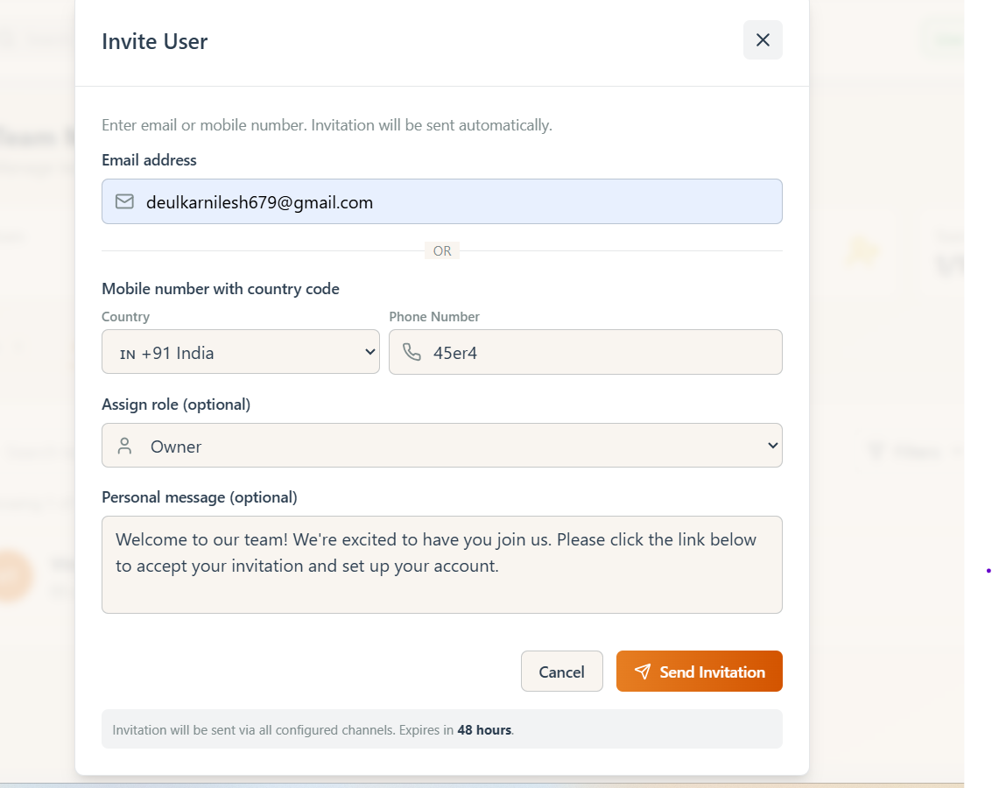

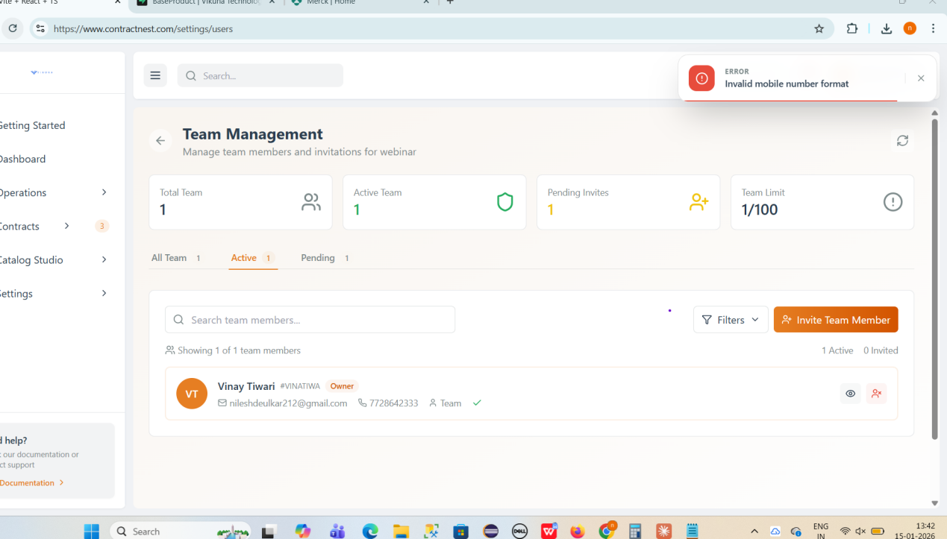

**After sending 2 invites still its showing 0 and Invitation not received on mention email id**

**Emailid-** [**deulkarnilesh679@gmail.com**](mailto:deulkarnilesh679@gmail.com) **( Active)**

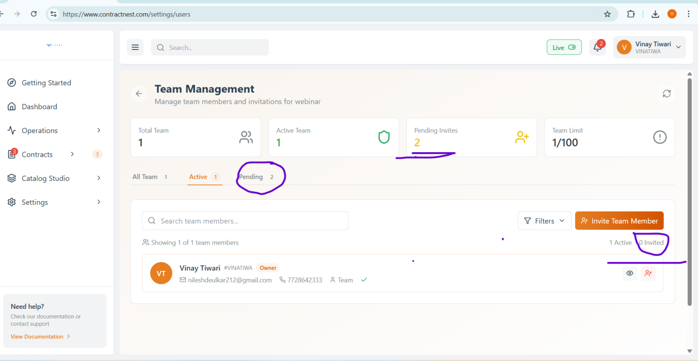

**After sending invite to user, pending count has not been Auto refresh**

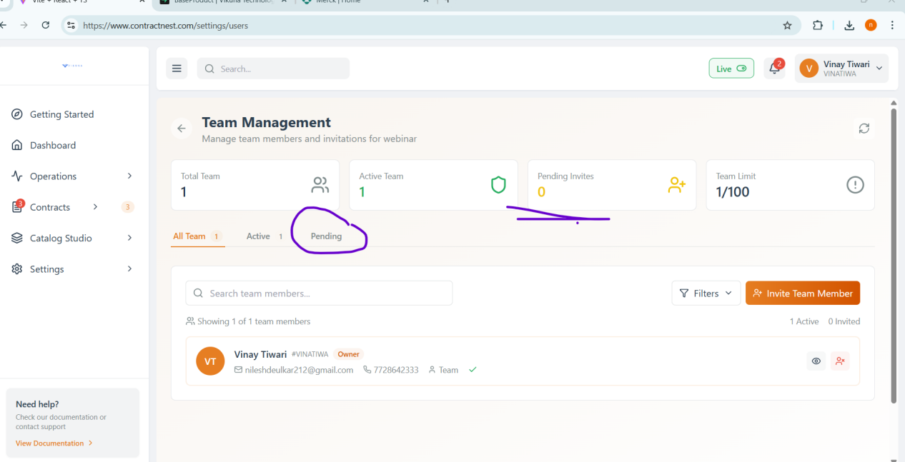

**After click on pending count its updated - Async issue**

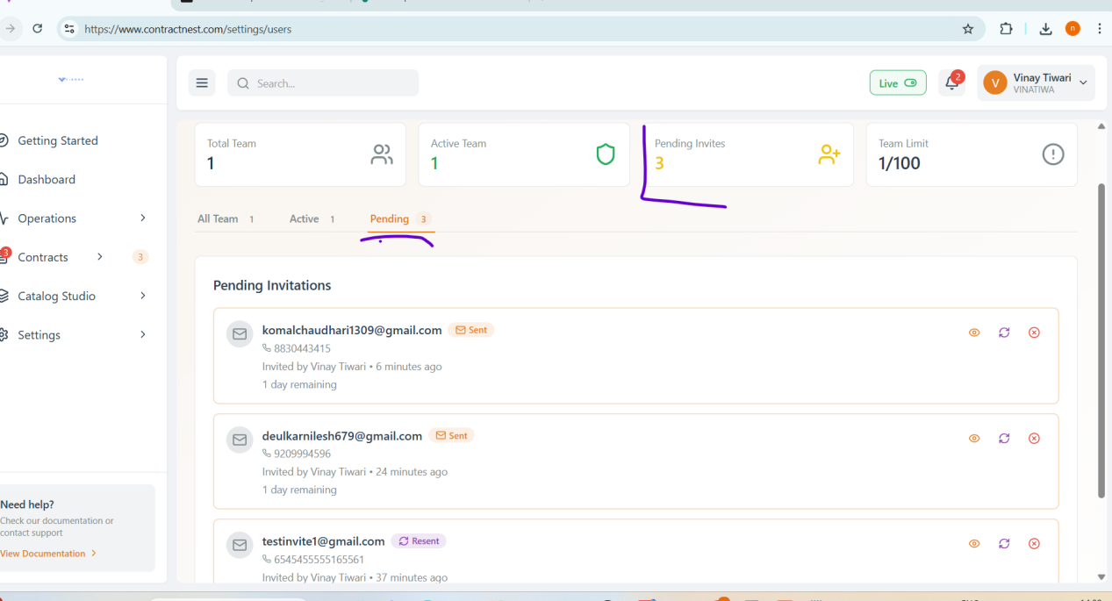

**Invite Sent to ID** [**-deulkarnilesh679@gmail.com**](mailto:-deulkarnilesh679@gmail.com) **and accepted it but in active tab wrong user is reflected.**

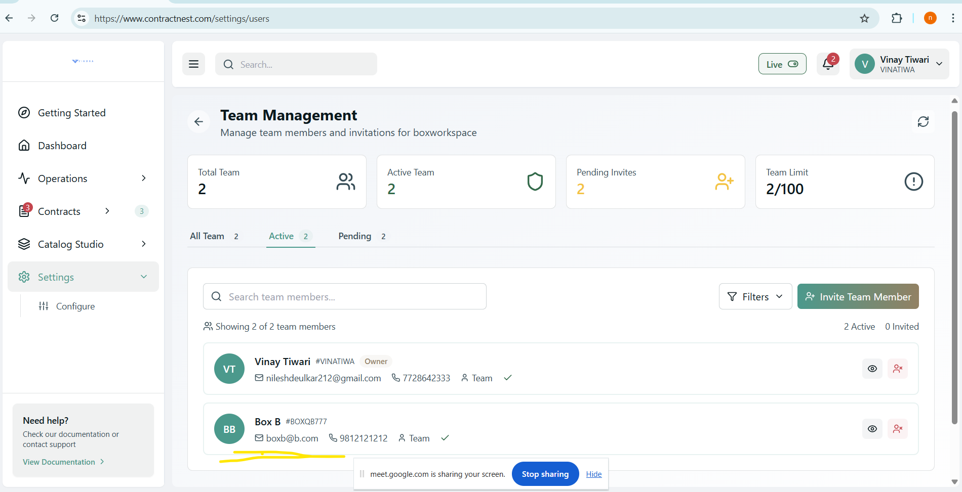

**Contractnest/vikuna logo is not clearly visible**

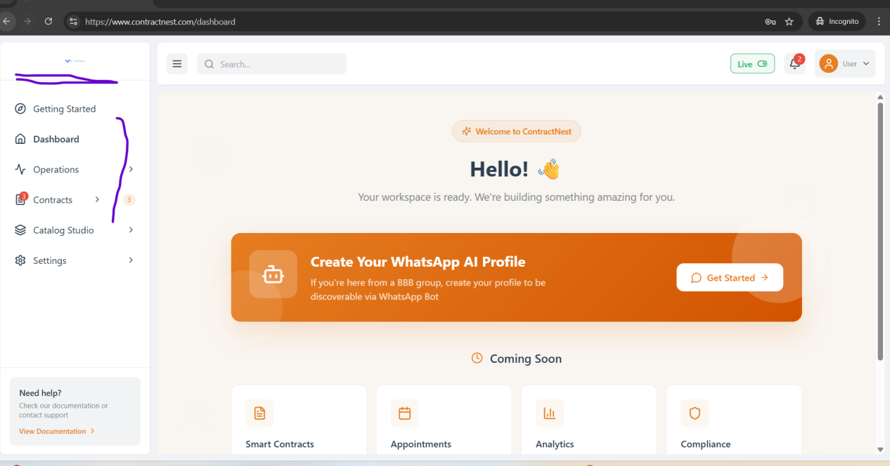

**Module-Contacts**

**Entities help management needs more description about entities,may be it is in development phase-**

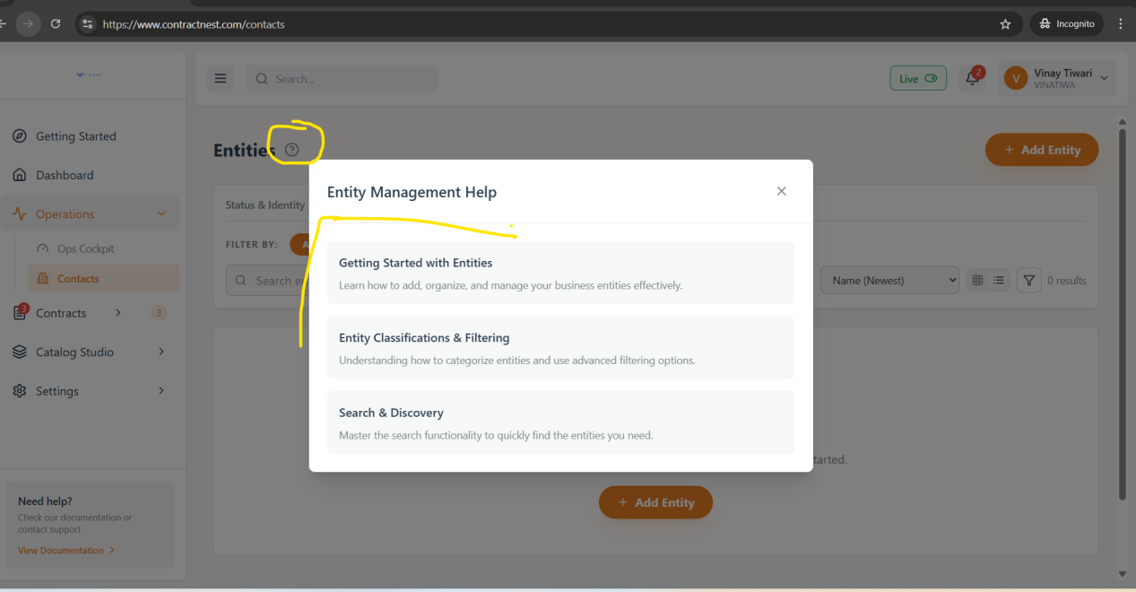

**Issue Description- API request fails with "Error 400 - Bad Request" when attempting to create a Corporate Buyer entity through the Quick Add Entity form and +add another channel as “Phone”**

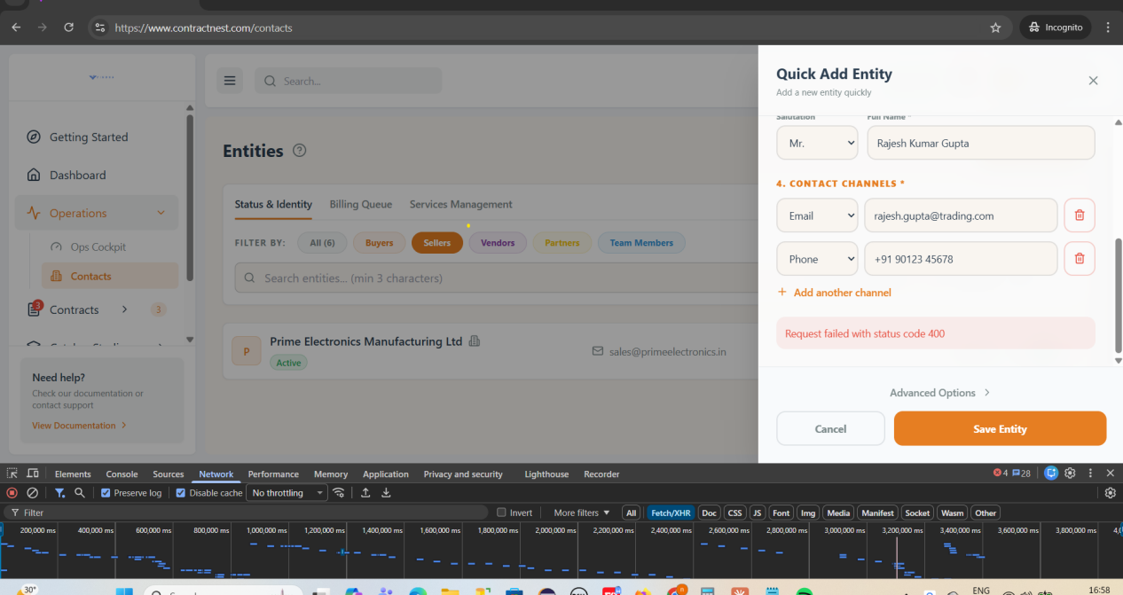

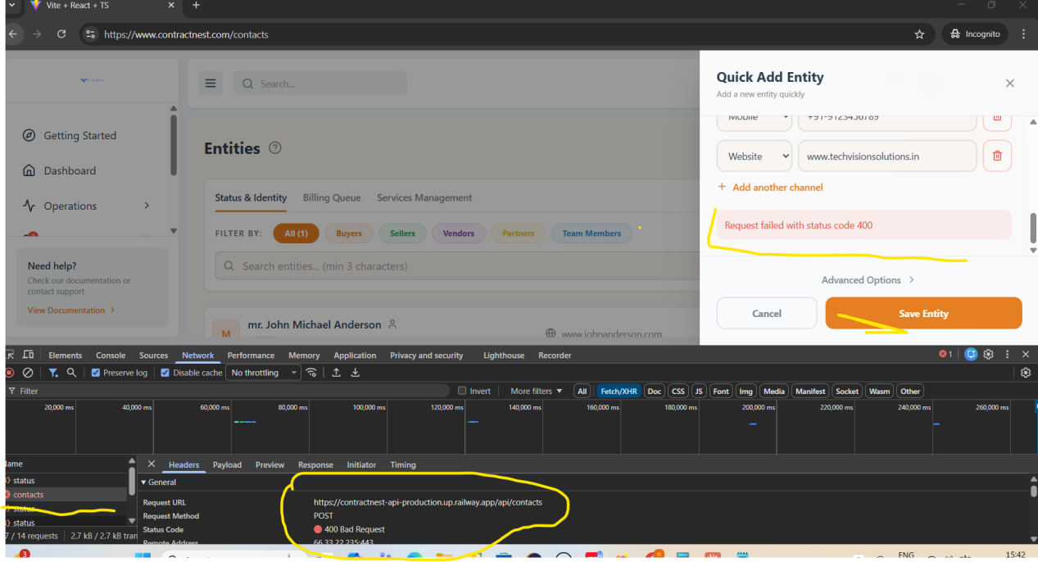

Logs---

POST https://contractnest-api-production.up.railway.app/api/contacts 400 (Bad Request)

(anonymous) @ index-B2QfQWLQ.js:7938

apply @ index-B2QfQWLQ.js:7938

(anonymous) @ index-B2QfQWLQ.js:62

xhr @ index-B2QfQWLQ.js:62

iee @ index-B2QfQWLQ.js:64

Promise.then

_request @ index-B2QfQWLQ.js:65

request @ index-B2QfQWLQ.js:64

(anonymous) @ index-B2QfQWLQ.js:65

(anonymous) @ index-B2QfQWLQ.js:60

mutate @ index-B2QfQWLQ.js:8706

$ @ index-B2QfQWLQ.js:9235

WX @ index-B2QfQWLQ.js:48

(anonymous) @ index-B2QfQWLQ.js:48

tY @ index-B2QfQWLQ.js:48

cz @ index-B2QfQWLQ.js:48

kz @ index-B2QfQWLQ.js:49

y0e @ index-B2QfQWLQ.js:49

n @ index-B2QfQWLQ.js:7938

**Failed to archive contact after clicked on delete button-**

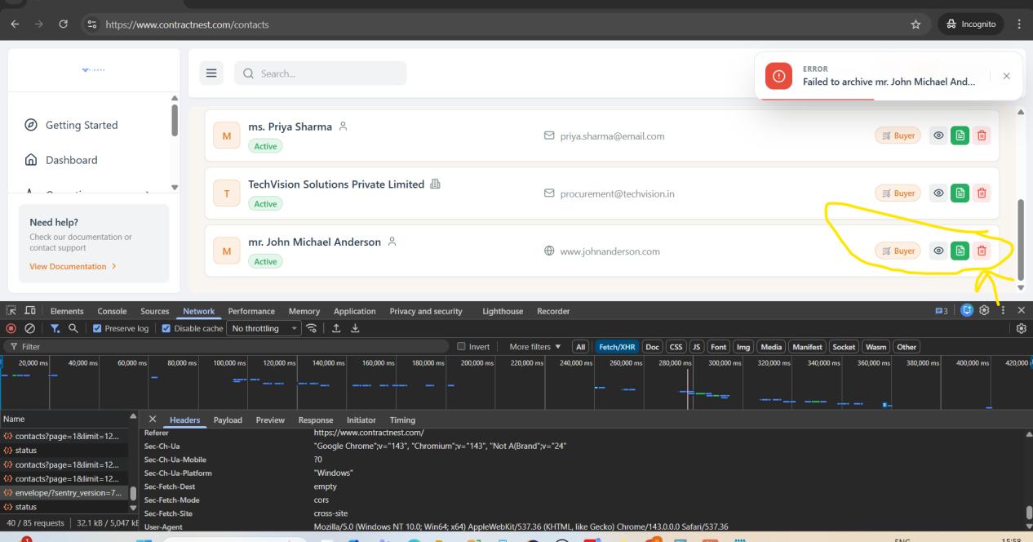

**When we refresh the page its redirecting to the ALL tab it should stay at last selected tab--**

**Added the new seller entity and refresh it then it redirected to the all tab .**

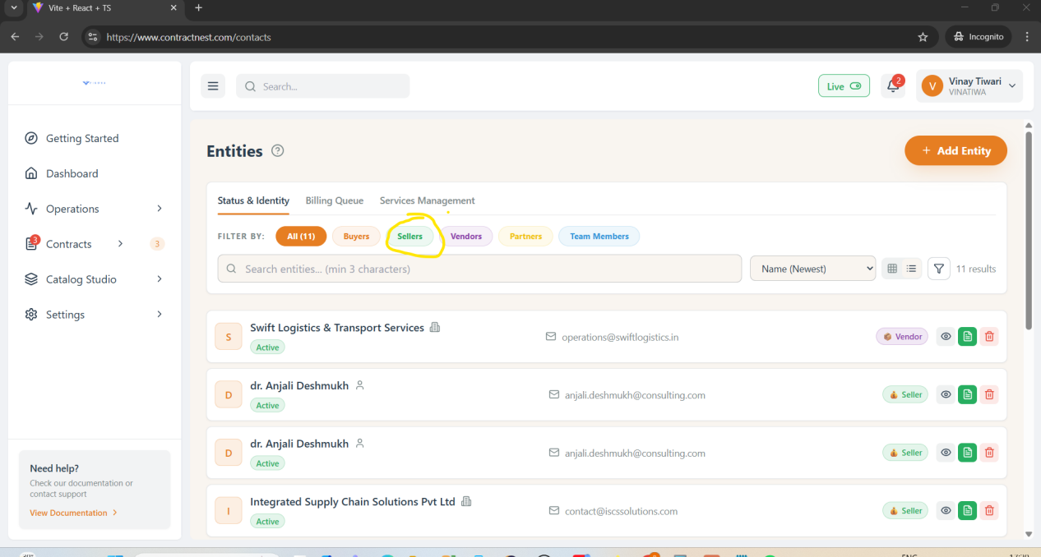

**Need to discuss --Unable to create Entity with Partner + Individual person --**

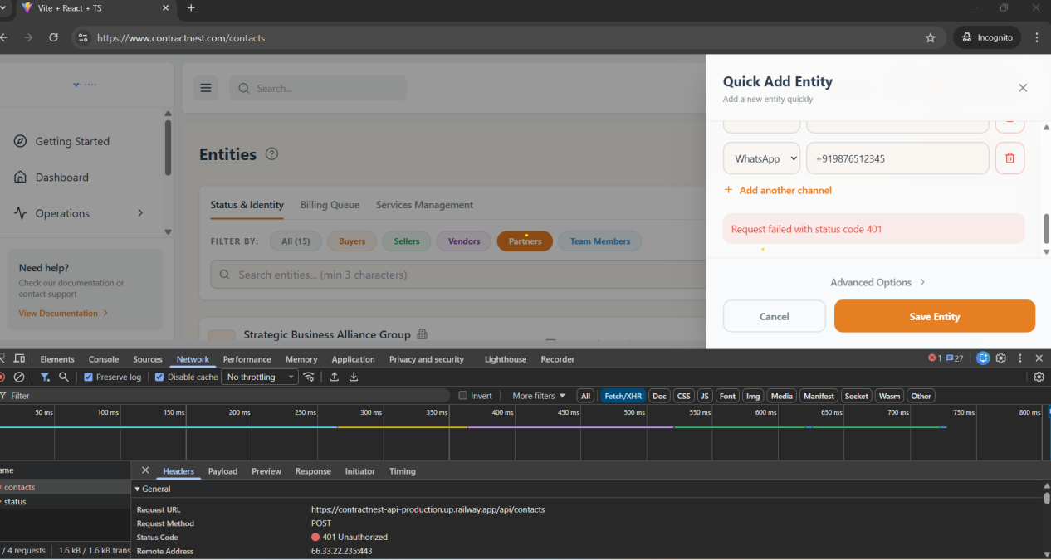

**The filter is not working as expected. Even after filtering by old date created, the entries remain in the same order. The most recent entry (testemailformat) is still displayed at the top.**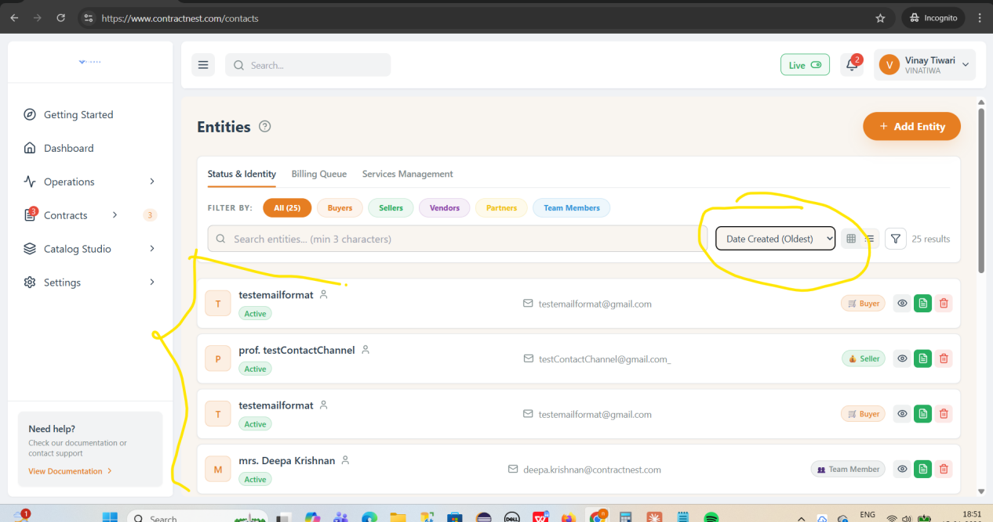

**Mobile Format accepting above 10 digit till14 and Incomplete 8 digit place**

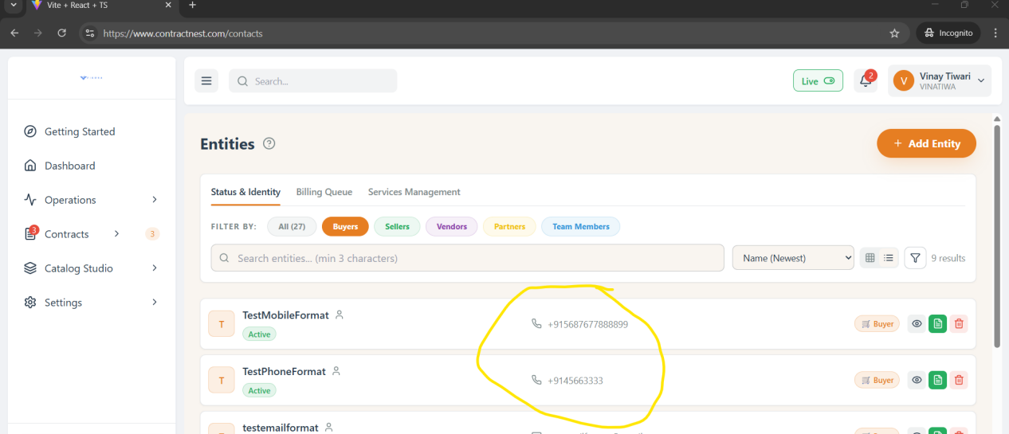

**Name Field is accepting Special Characters---**

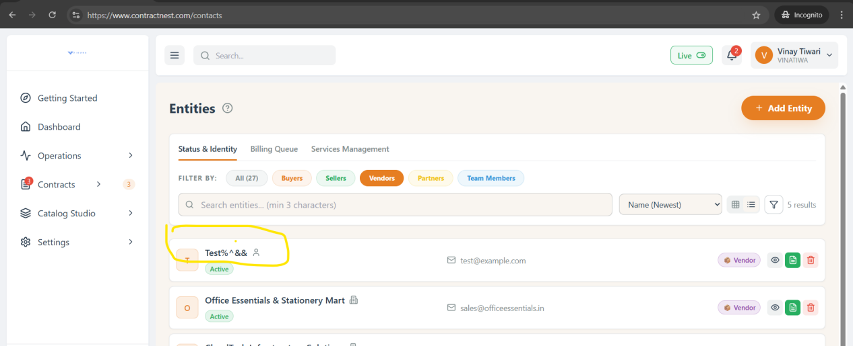

**Duplicate Contact entries allowed in system--**   
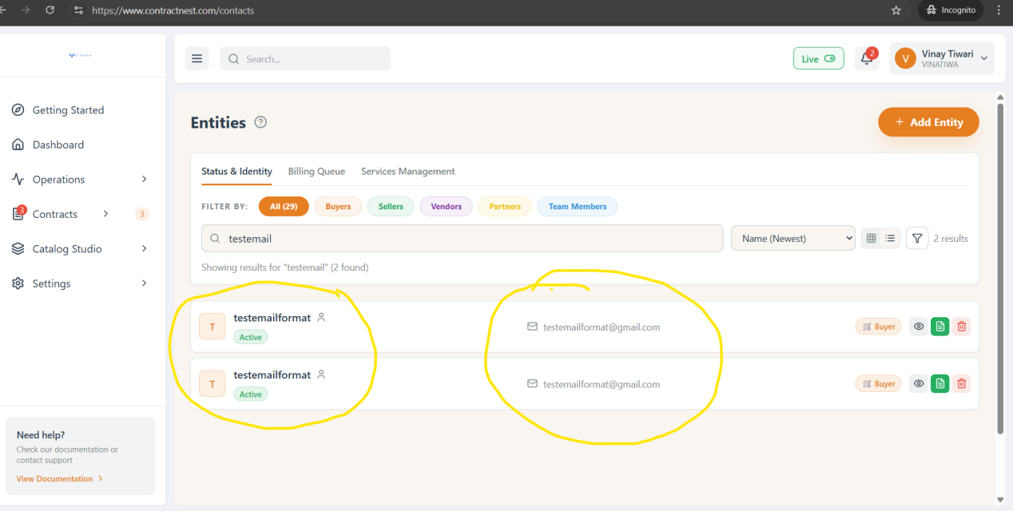

**One user can create with multiple roles like Buyer/seller/partner need to discuss it,..**

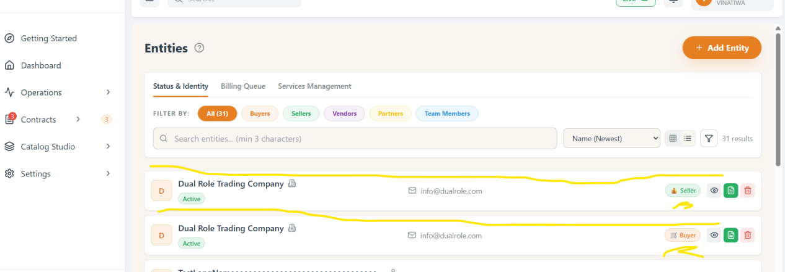

**Settings-Configure-Resource Mnagement-**

**After deleting equipment entry its sequesnce is not auto adjust by skipping deleted entry..**

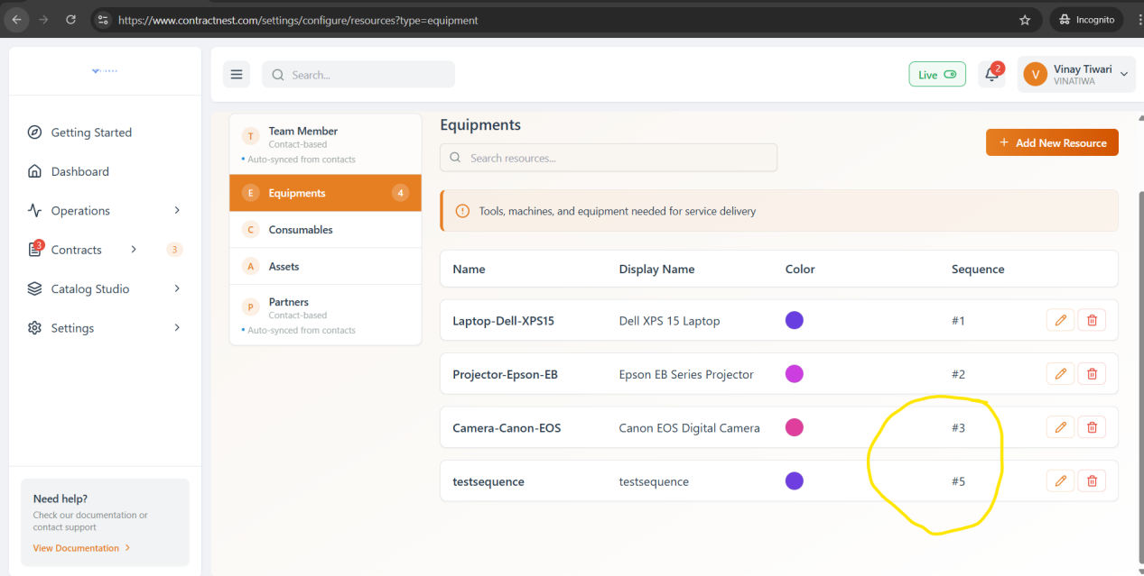

**Settings-Configure--Resource Management**

**After Adding contacts Team Members and Partners these are reflecting in Team member and partner but not appropriate**

**Color and sequence is empty and edit option is not present to mannual update.**

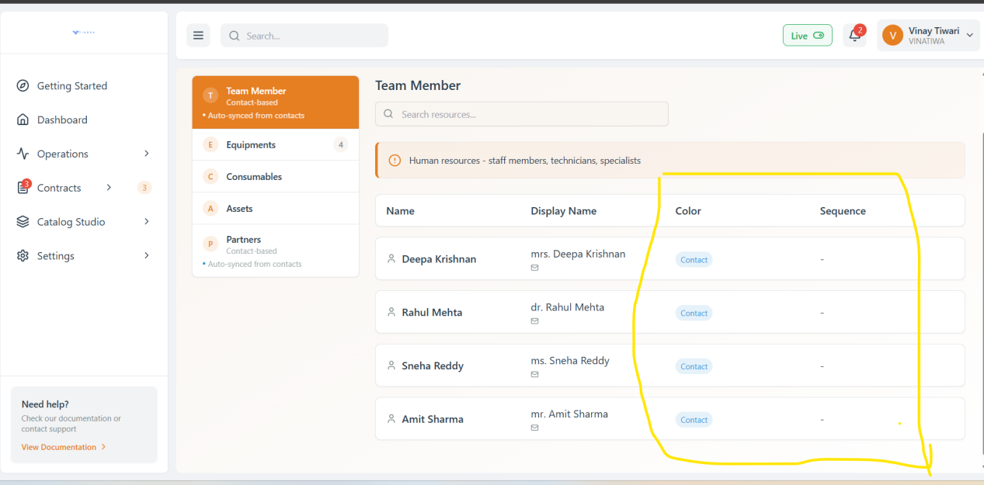

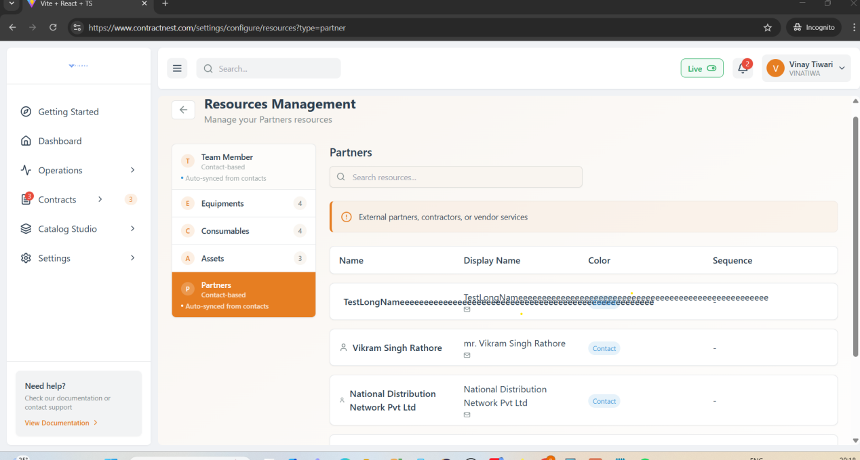

**Setting-Configure-ListOfValues-**

**Showing error while adding new LOV**

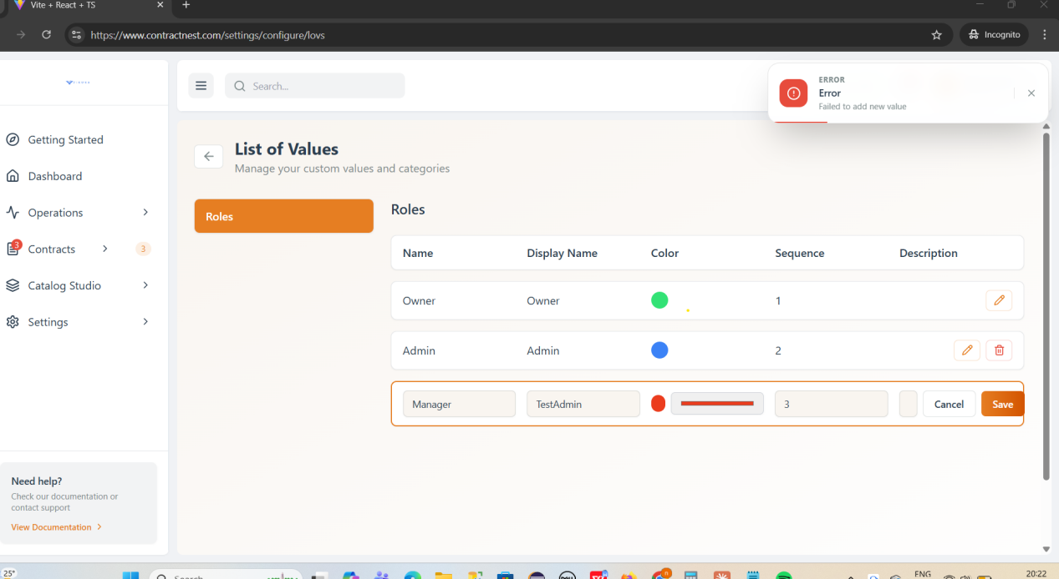

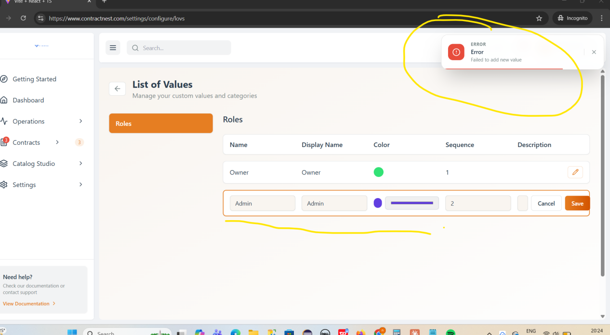

**While adding LOV Description space is showing but it is not editable**

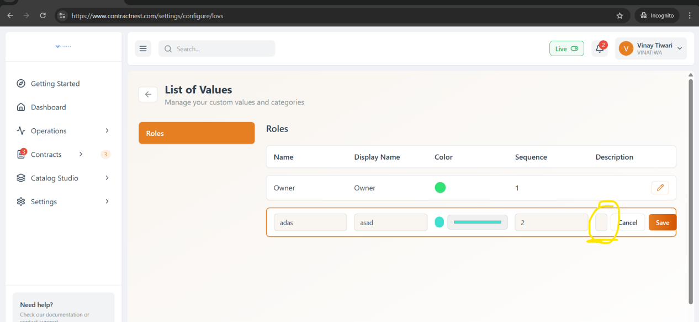

**Settings-Configure-Storage Management**

**After clicking on contact photos, the image is not downloaded and only opens in view mode.**

**Action menu download is not downloaded image**

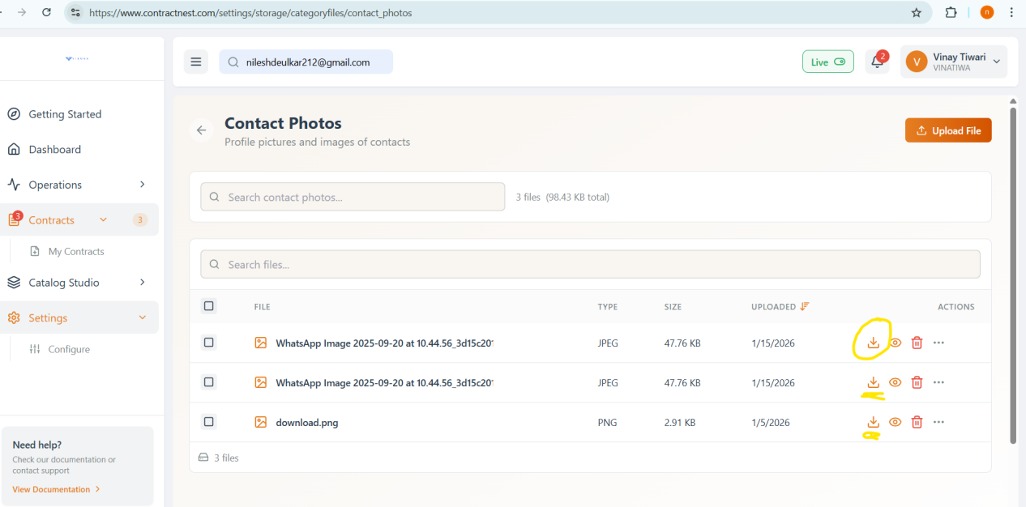

The **Actions menu** is **overlapping** with the **Download, Preview (View), and Delete** options in the contact photos section. Due to this overlap, the options are not displayed clearly and create a UI alignment issue.

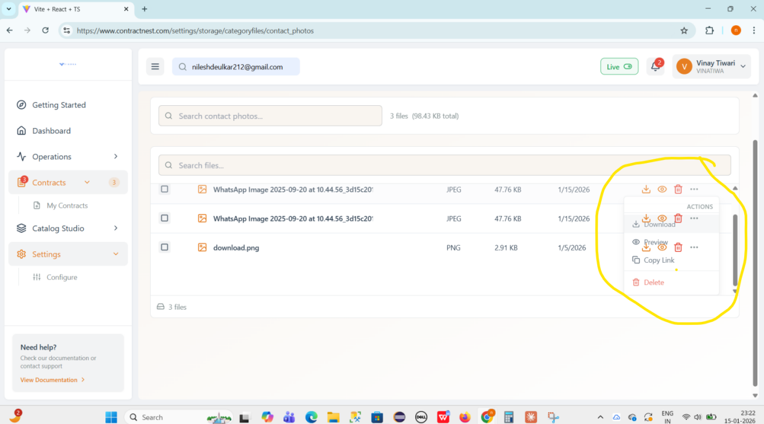

In the **Contact Photos** section, uploading **multiple files/photos** fails and the system throws an **“unexpected end of form”** error.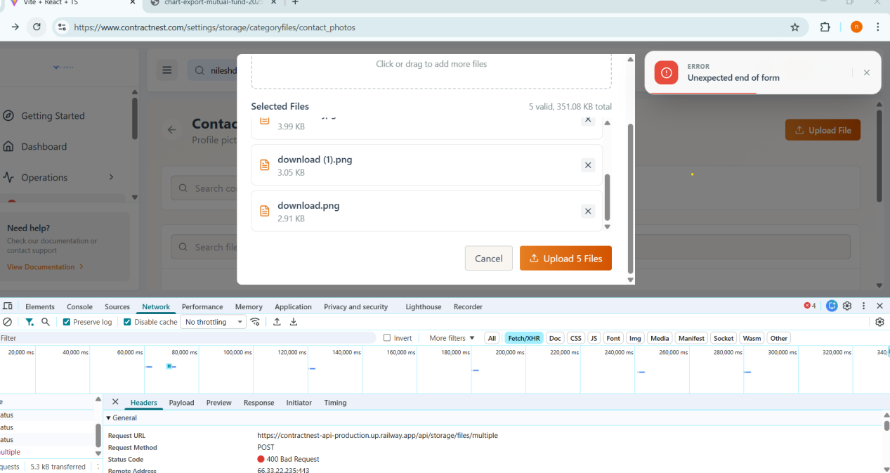

**In storage Mangement while loading conatact photo/contract/documents circular loader is running istead of vani..so need to confirm if it is expected or not ??**

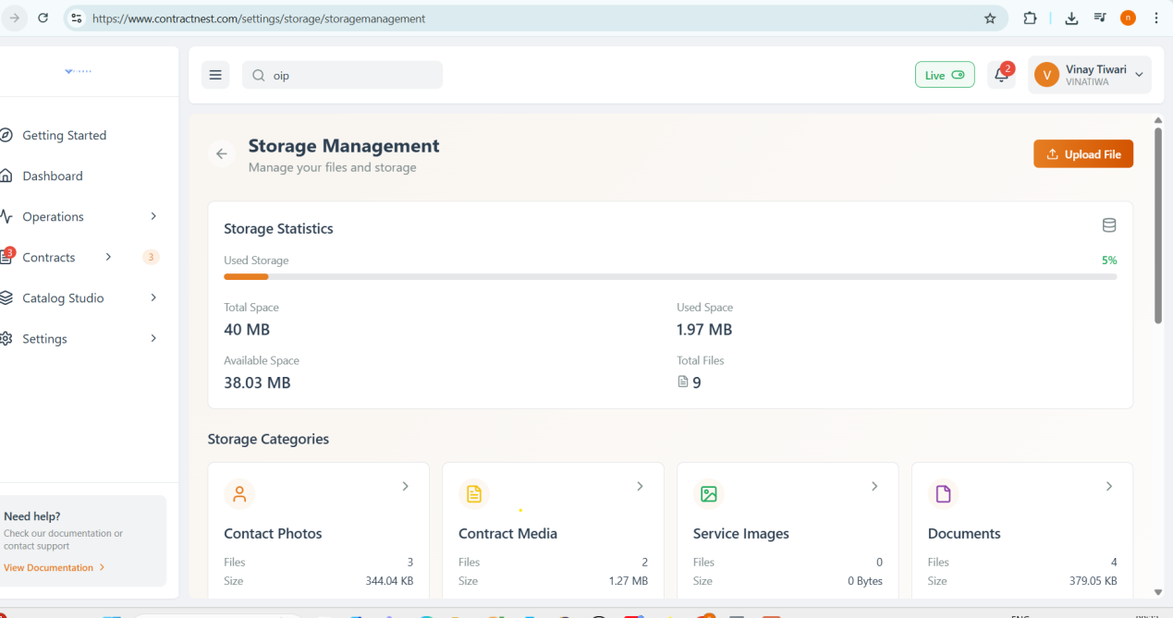

**A UI issue is observed where additional space is displayed and can be reduced. There is also a text and UI alignment issue in the Actions section**.

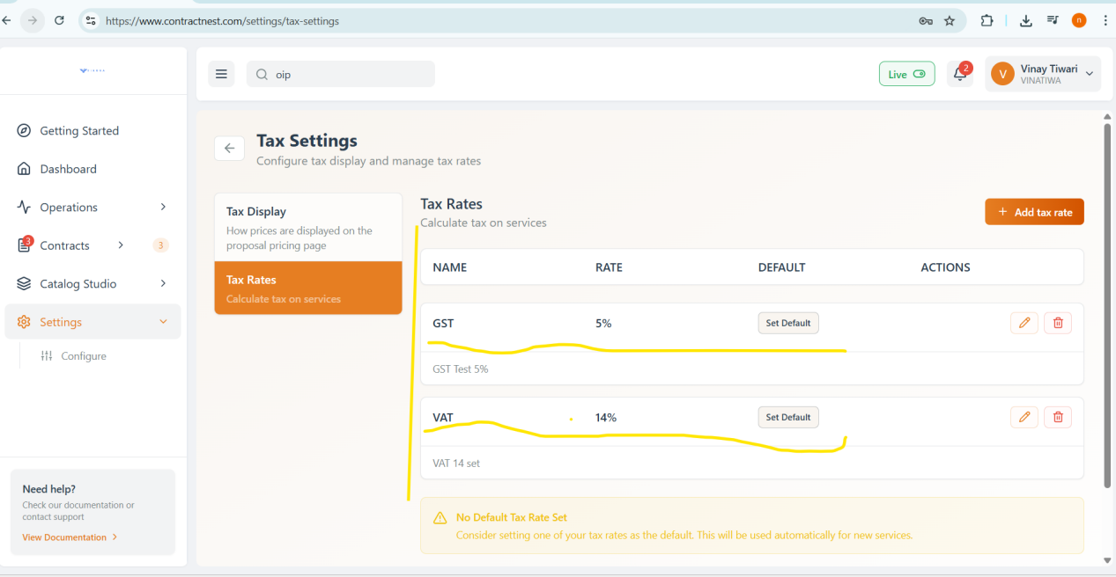

**Settings-configure-Business profile**

**Business profile creation failed**

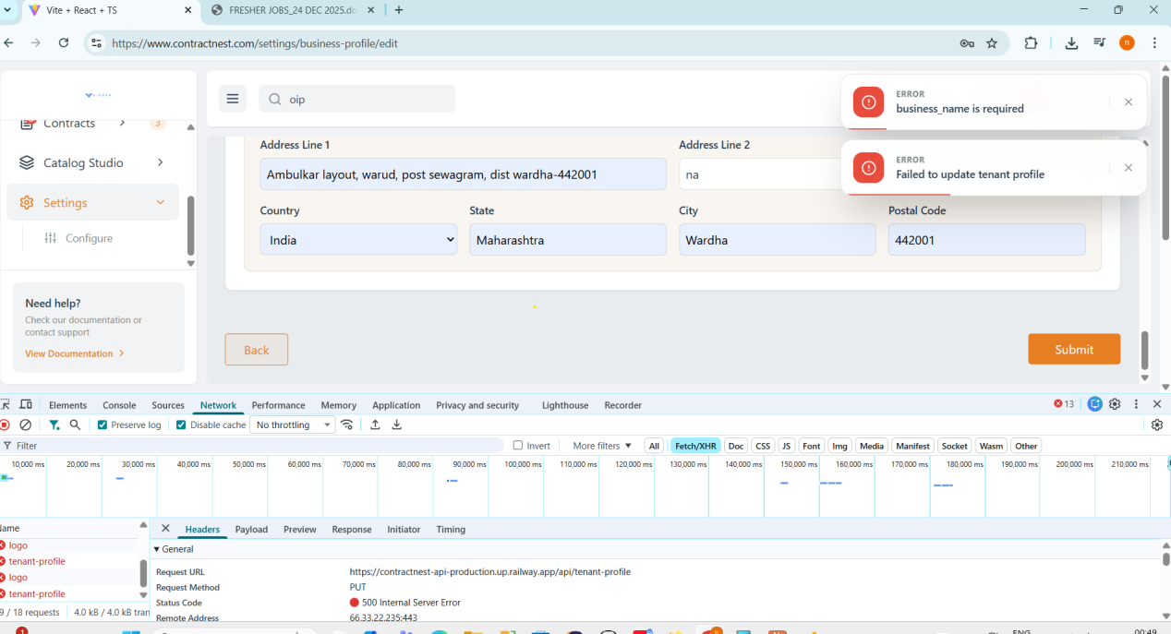

In **Settings → Configure → Sequence Numbers**, after editing the **contact digit** and clicking **Confirm Retest**, the application throws an error.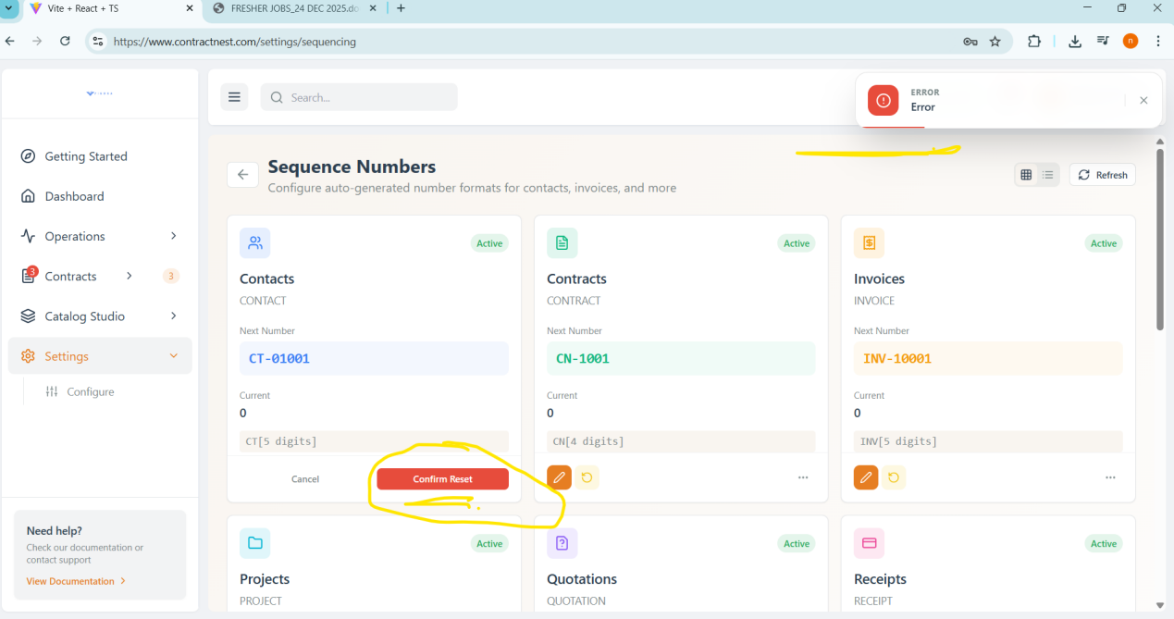

**The three-dot (more options) menu is not active and cannot be clicked.**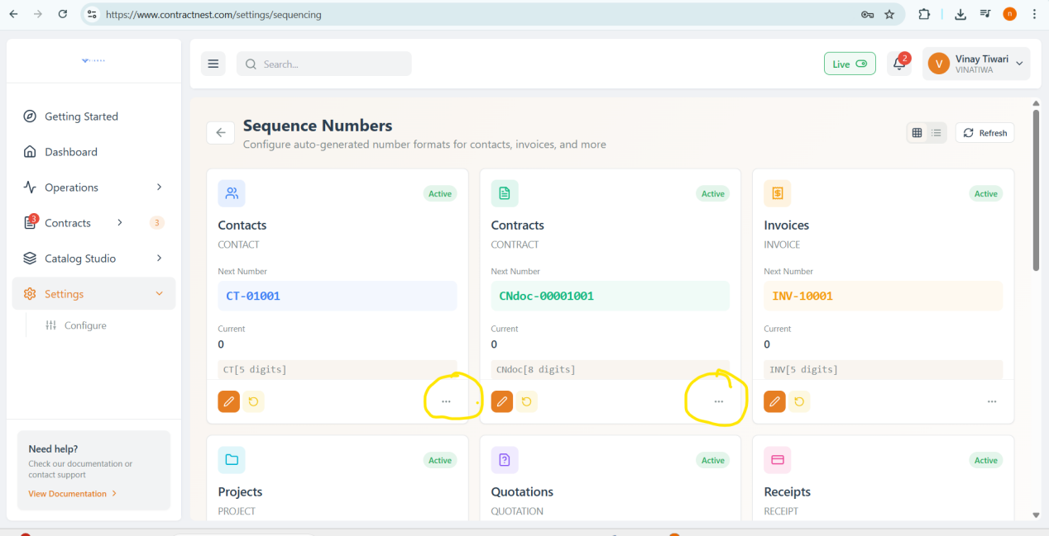

**Points to Discuss-**

**2 Search are there in Storage Categories card--**

**Search at top of the page is not active**

